Mid-Term Examination (July -Dec - 2020)

01.a) Let say; you are wearing on your wrist one of the world’s most common types of objects—a watch. Discuss how each of the following terms and concepts applies to the notion of a watch:
Object, Attributes, Behaviors, Class, Inheritance (consider, for example, an alarm clock), Abstraction, Modeling, Messages, Encapsulation, Interface, Information hiding. (4 marks)
Sol^{n}:
Already solve.

01.b) Identify and correct the errors in each of the following statements:
i) if (c < 7); System.out.println(“c is less than 7”);
ii) if (c == 7) System.out.println(“c is equal to or greater than 7”);
(2 marks)
Sol^{n}:
i) Error: semicolon ( ; ) ends the if statement early.
Correct:
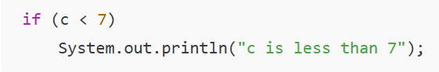
ii) Error: message text doesn’t match the condition (c == 7 not “greater than 7”).
Correct:
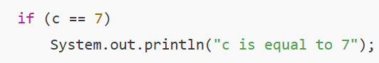

01.c) Write declarations, statements, or comments that accomplish each of the following tasks:
i) State that a program will calculate the product of three integers.
ii) Create a Scanner called input that reads values from the standard input.
iii) Declare the variables x, y, z, and result to be of type int.
iv) Read the first integer from the user and store it in the variable x. (2 marks)
Sol^{n}:
1  2  3  4  5  6  7  8  9  10  11  12  13  14  15  16 | // i) This program calculates the product of three integers.  import java.util.Scanner;  public class Product {  public static void main(String[] args) {  // ii) Create a Scanner called input  Scanner input = new Scanner(System.in);  // iii) Declare variables  int x, y, z, result;  // iv) Read first integer from user  System.out.print("Enter first integer: ");  x = input.nextInt();  }  }

02. a) Create a class Rectangle with attributes length and width, each of which defaults to 1. Provide methods that calculate the rectangle’s perimeter and area. It has set and get methods for both length and width. The set methods should verify that length and width are each floating-point numbers larger than 0.0 and less than 20.0. Write a program to test class Rectangle. (4 marks)

Sol^{n}:
1  2  3  4  5  6  7  8  9  10  11  12  13  14  15  16  17  18  19  20  21  22  23  24  25  26  27  28  29  30  31  32  33  34  35  36  37 | class Rectangle {  private double length = 1, width = 1;  public Rectangle() {} // default  public Rectangle(double l, double w) {  setLength(l);  setWidth(w);  }  public void setLength(double l) {  if (l > 0 && l < 20) length = l;  }  public void setWidth(double w) {  if (w > 0 && w < 20) width = w;  }  public double getLength() {  return length;  }  public double getWidth() {  return width;  }  public double perimeter() {  return 2 * (length + width);  }  public double area() {  return length * width;  }  public static void main(String[] args) {  Rectangle r = new Rectangle(5, 3);  System.out.println("Length: " + r.getLength() + ", Width: " + r.getWidth());  System.out.println("Perimeter: " + r.perimeter() + ", Area: " + r.area());  r.setLength(10);  r.setWidth(8);  System.out.println("Updated Perimeter: " + r.perimeter() + ", Updated Area: " + r.area());  }  }

2. b) Discuss the ways in which inheritance promotes software reuse, saves time during program development, and helps prevent errors. (3 marks)
Sol^{n}:
Inheritance allows a class to reuse attributes and methods of an existing class, reducing the need to write code again. This saves time during program development because new classes can be created quickly by extending existing ones. It also helps prevent errors, as reused code is already tested and reliable, ensuring consistency across the program.

